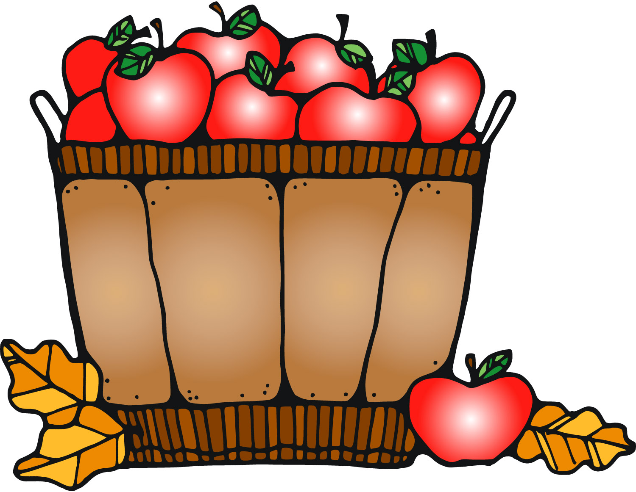 **Grade 2C October 2025**

|  |  |  |  |  |  |  |  |
| --- | --- | --- | --- | --- | --- | --- | --- |
| **Sun** | **Mon** | **Tue** | **Wed** | **Thu** | **Fri** | **Sat** | |
|  |  |  | 1 | 2 | 3 | 4 | |
|  |  | **No School**  **National Day of Truth & Reconciliation** | Library  Image result for early dismissal clipart  2:19 pm | Bible Memory Matthew 22:39  Spelling Week 5  Parent: Groen | **PD Day- No School** |  | |
| 5 | 6 | 7 | 8 | 9 | 10 | 11 | |
|  | Read in Week Image result for reading clipart | Chip Day  Library | Character Dress Up Day  Image result for early dismissal clipart |  | **Thanksgiving**  **Chapel 9:15**  Spelling Week 6  Bible Memory  Matthew 22:40  Parent: Fair |  | |
| 12 | 13 | 14 | 15 | 16 | 17 | 18 | |
| Happy birthday, Ethan! | Happy birthday, Levi!  **Happy Thanksgiving!**  No  School | Library | Image result for early dismissal clipart |  | **Hot Lunch**  Spelling Week 7  Bible Memory  Matt. 22: 37-40  Parent: Fair |  | |
| 19 | 20 | 21 | 22 | 23 | 24 | 25 | |
|  |  | Chip Day  Picture Retakes  Library | Image result for early dismissal clipart |  | Spelling Week 8  Parent: Cole |  | |
| 26 | 27 | 28  Library | 29  Image result for early dismissal clipart | 30 | 31  Spelling week 9 Bible memory  Matthew 28:19  Parent: Cuthbertson  Happy birthday, Teni! | |  |